Name: Brandon McDonald
Date: October 20th, 2021
08.06 Picture Lab Worksheet
Directions: Make note of your responses to the following questions as you work through the activities and exercise in the lesson.

Activity 1 Questions
- How many bits does it take to represent the values from 0 to 255?
8 Bits
- How many bytes does it take to represent a color in the RGB color model?
3 Byte
- How many pixels are in a picture that is 640 pixels wide and 480 pixels high?
307,200

Activity 2 Questions
- How can you make pink?
java.awt.Color[r=255,g=51,b=255]
- How can you make yellow?
java.awt.Color[r=255,g=255,b=51]
- How can you make purple?
java.awt.Color[r=102,g=0,b=204]
- How can you make white?
java.awt.Color[r=255,g=255,b=255]
- How can you make dark gray?
java.awt.Color[r=51,g=51,b=51]

Activity 3 Questions
- What is the row index for the top left corner of the picture?
0
- What is the column index for the top left corner of the picture?
0
- The width of this picture is 640. What is the right-most column index?
640
- The height of this picture is 480. What is the bottom-most row index?
480
- Does the row index increase from left to right or top to bottom?
Top to Bottom
- Does the column index increase from left to right or top to bottom?
Left to Right
- Set the zoom to 500%. Describe what you see.
Pixelated version of the image as the
colors do not blend together as much

Activity 3 Exercise Results

- After modifying the main method in the PictureExplorer class to create and explore a different picture from the images folder, paste the code below.
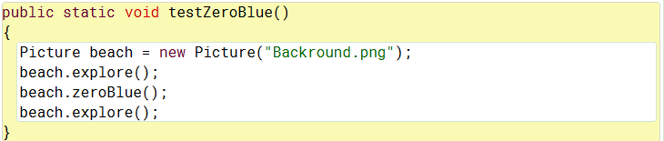

- After scaling your image, paste the new main method code below.
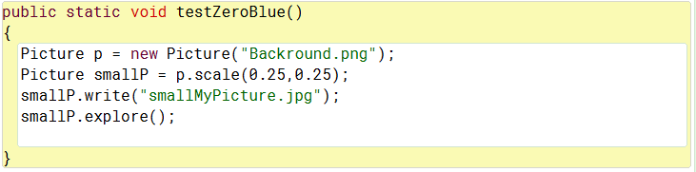

Activity 4 Exercise Results
- What was the output result after running the getCount method?
Paste your getCount method below.

“Count should be 6 and count is 6”
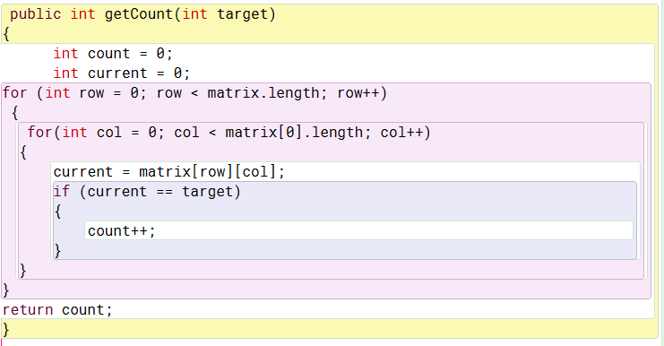

- What is the output result after running the getLargest method?
Paste your getLargest method below.
“Largest should be 6 and is 6
Largest should be 6 and is 6
Largest should be 6 and is 6
Largest should be 6 and is 6”
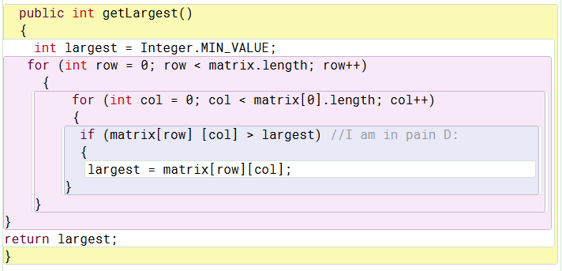
- What is the output result after running the getColTotal method?
Paste your getColTotal method below.
“Total for column 0 should be 5 and is 5
Total for column 1 should be 7 and is 7
Total for column 2 should be 9 and is 9”
